EXCLUSIONS IN SAM: WHAT SHOULD CONTRACTING PROFESSIONALS BE DOING AND WHAT SHOULD CONTRACT WRITING SYSTEMS (CWS) BE SHOWING?
Contracting professionals must review the details regarding an entity exclusion in SAM. You cannot just do a search in SAM and say, ‘oh there’s an exclusion, I can’t award to this entity’. Exclusions contain different ‘Effects’. In some cases, you may be allowed to award to this entity, in others you are not. It is, therefore, imperative that you read the details of the exclusion, especially the effect
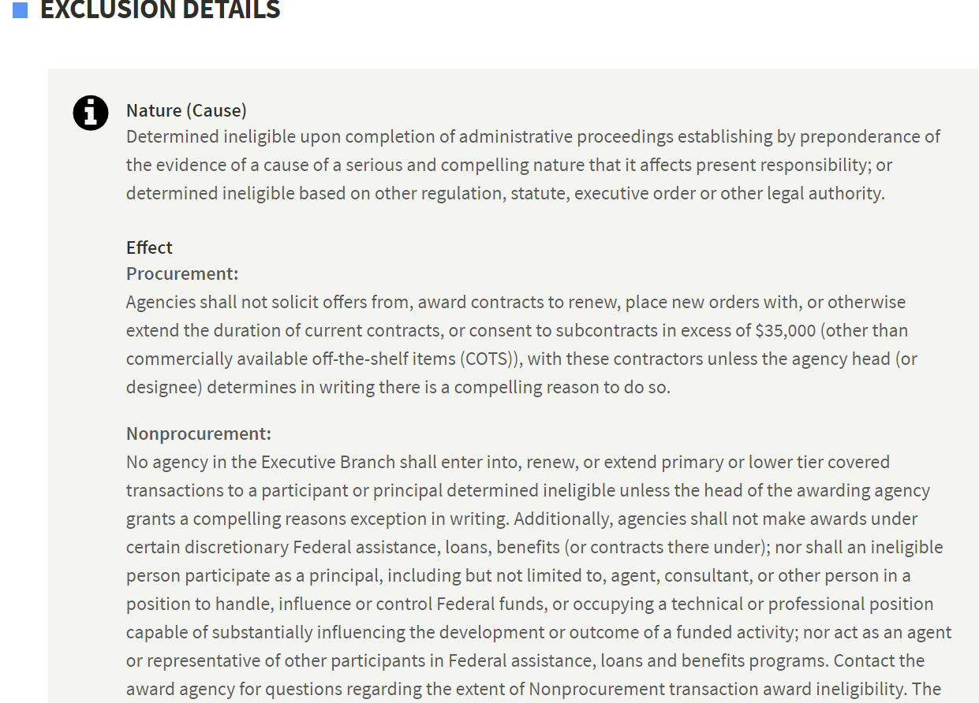

An Exclusion does NOT always mean you shouldn’t award to an entity. Look at the ‘Effect’ to determine what action you should take regarding the entity. The Effect of the exclusion must be read by the contracts officer.
Contract Writing Systems or Bots that just bring back a YES or NO or Y/N flag for exclusions or debarment and suspension are incorrect. The Effect of the exclusion must be read by the Contracting or Grants Officer.

